EXP NO 1: CREATE A SIMPLE CLOUD SOFTWARE APPLICATION FOR CAR BOOKING RESERVATION SYSTEM USING ANY CLOUD SERVICE PROVIDER TO DEMONSTRATE SAAS.
DATE:15/11/2025
DAY: SATURADAY
AIM: To Create a simple cloud software application for Car Booking Reservation System using any Cloud Service Provider to demonstrate SaaS.
PROCEDURE:
- Go to zoho.com. step
- Log into the zoho.com. step
- Select one application step. Step
- Enter application name as Car Booking Reservation System. step
- Created new application as Car Booking Reservation System. step
- Select one form step
- The software has been created.

OUTPUT: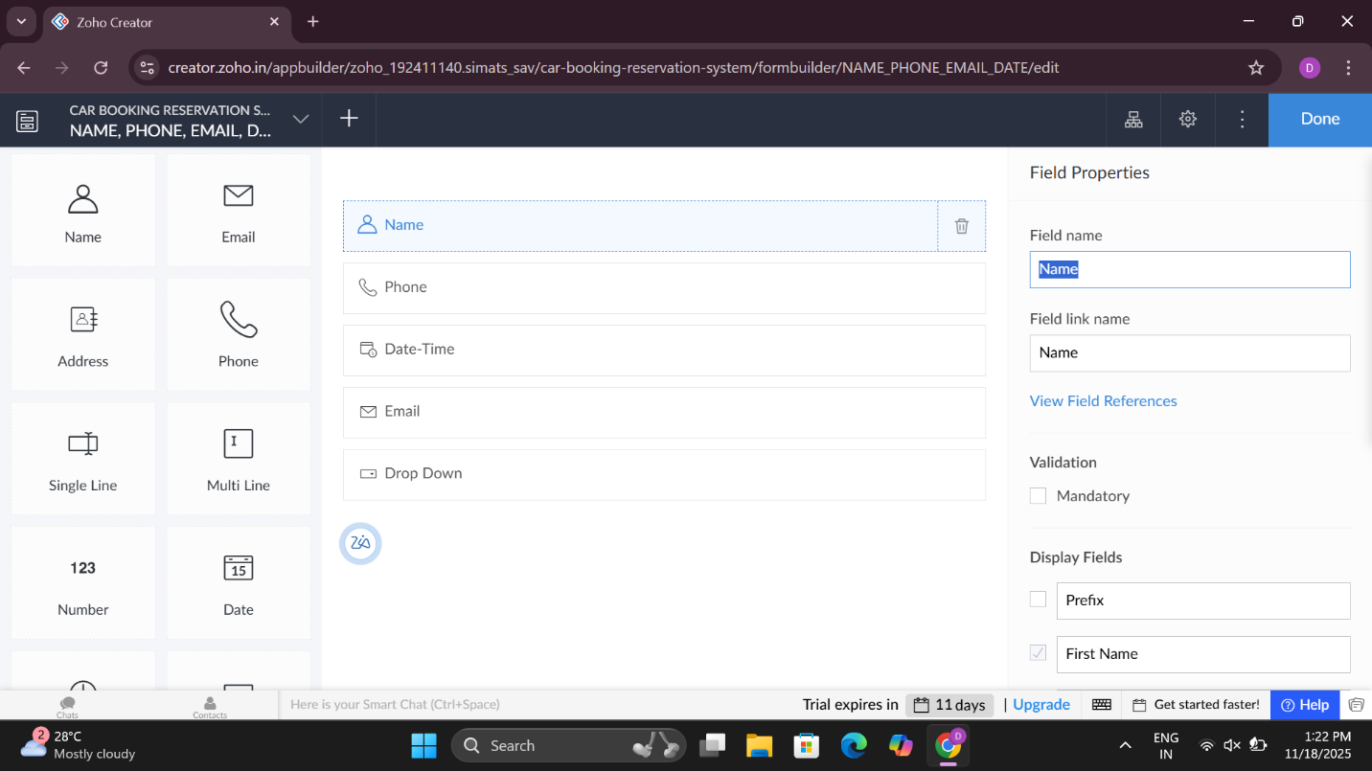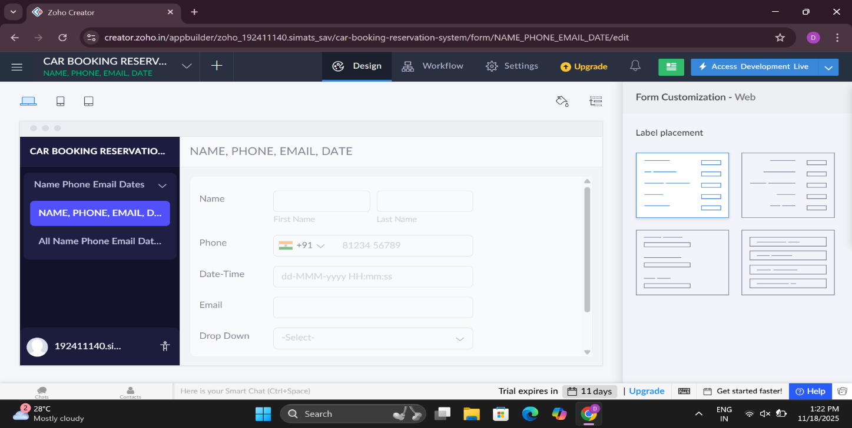

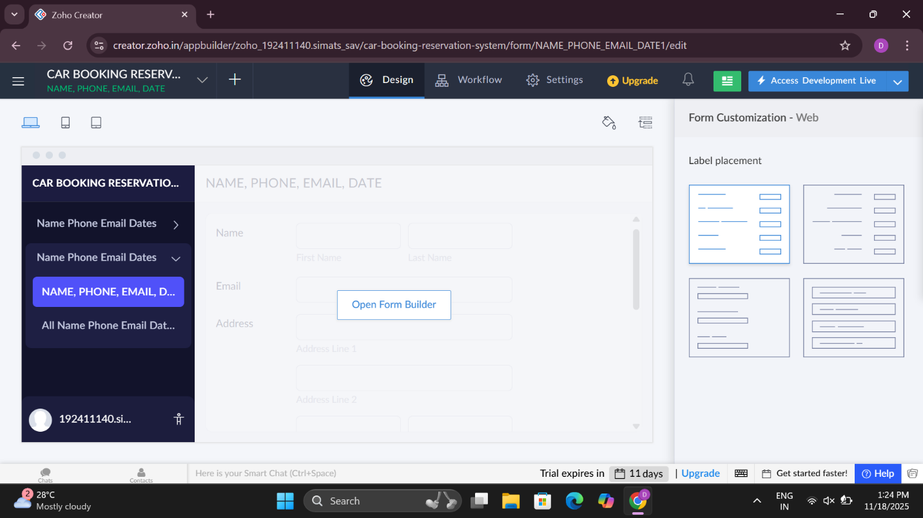

RESULT:

2. Create a simple cloud software application for HOSPITAL MANAGEMENT SYSTEM using any Cloud Service Provider to demonstrate SaaS.
DATE:15/11/2025
DAY: SATURADAY
AIM: To Create a simple cloud software application for HOSPITAL MANAGEMENT System using any Cloud Service Provider to demonstrate SaaS.

PROCEDURE:
- Go to zoho.com. step
- Log into the zoho.com. step
- Select one application step. Step
- Enter application name as Hospital Management System. step
- Created new application as Hospital Management System. step
- Select one form step
- The software has been created.

OUTPUT:
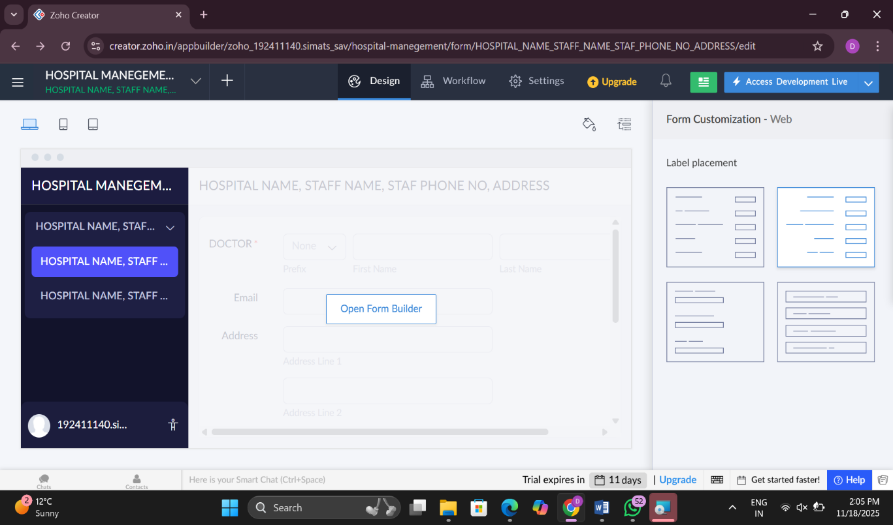

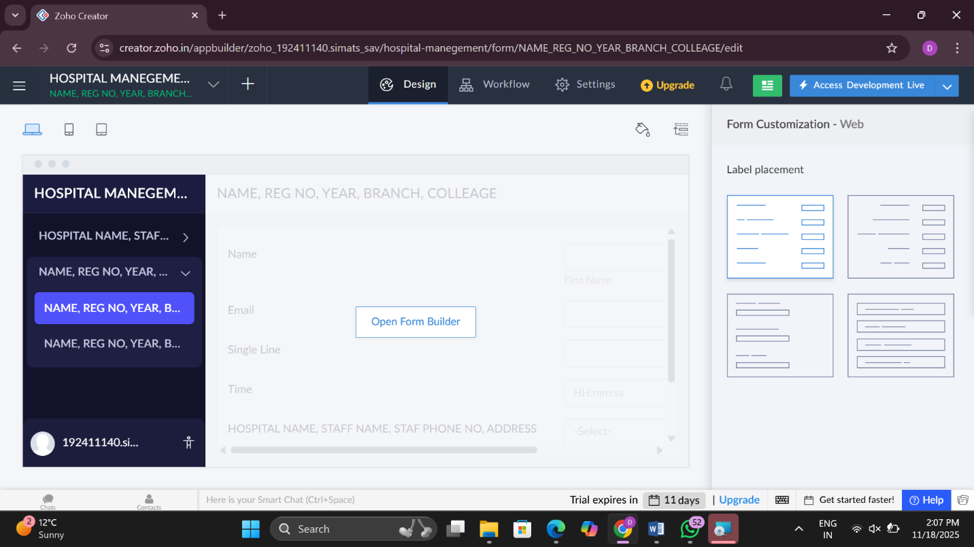

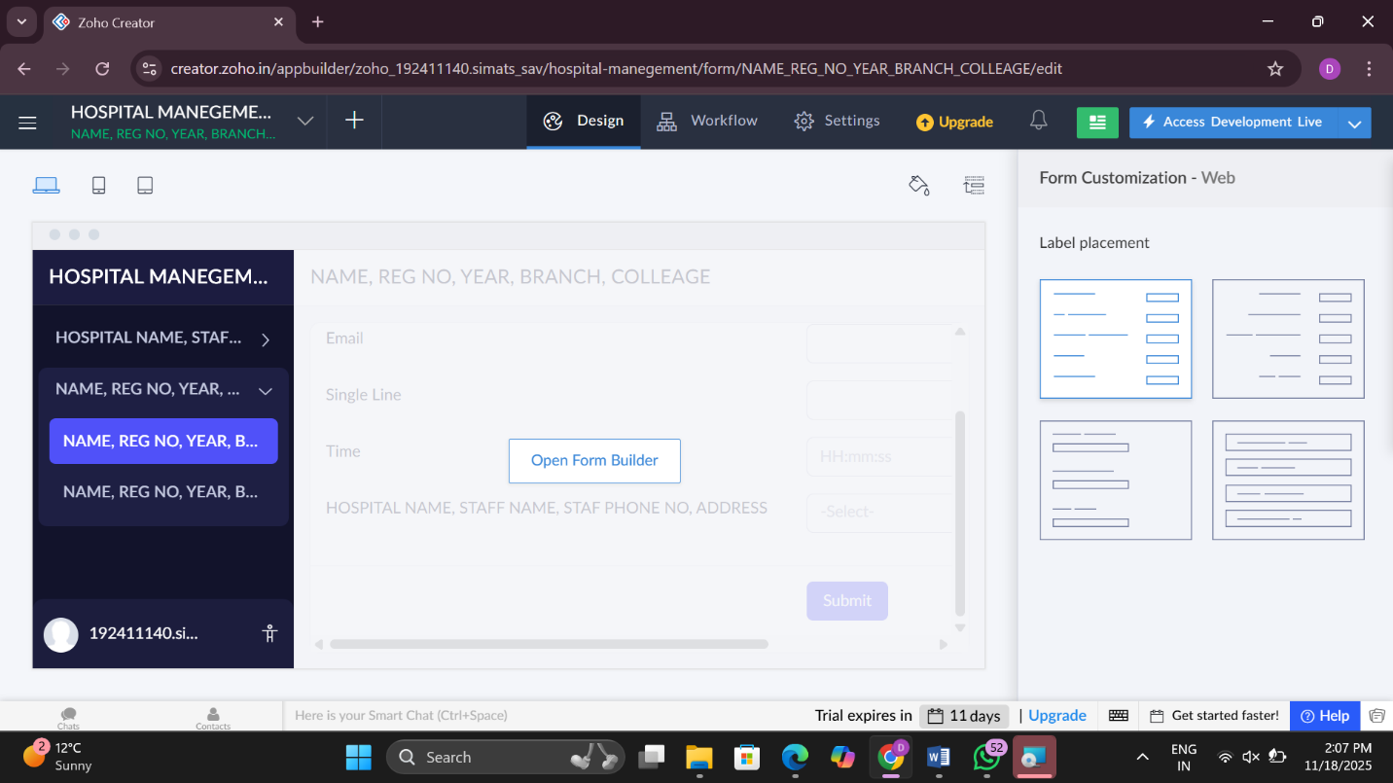

RESULT:

EXP 3: Create a simple cloud software applic4ation for Flight Reservation System using any Cloud Service Provider to demonstrate SaaS
DATE:15/11/2025
DAY: SATURADAY
AIM: To Create a simple cloud software application for Flight Reservation System using any Cloud Service Provider to demonstrate SaaS.
Procedure:]
- Go to zoho.com. step
- Log into the zoho.com. step
- Select one application step. Step
- Enter application name as Flight Reseravation System. step
- Created new application as Flight Reseravation System. step
- Select one form step
- The software has been created.
RESULT:
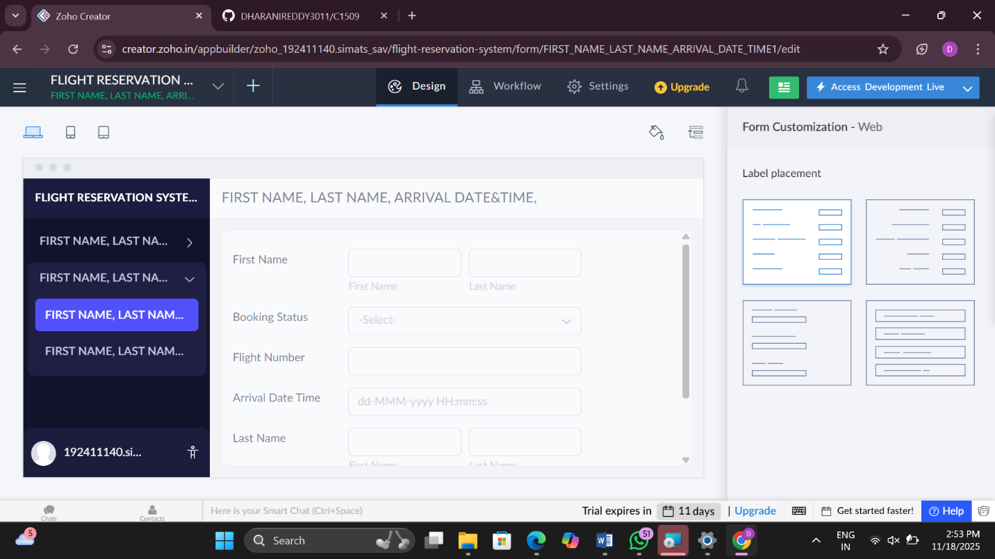

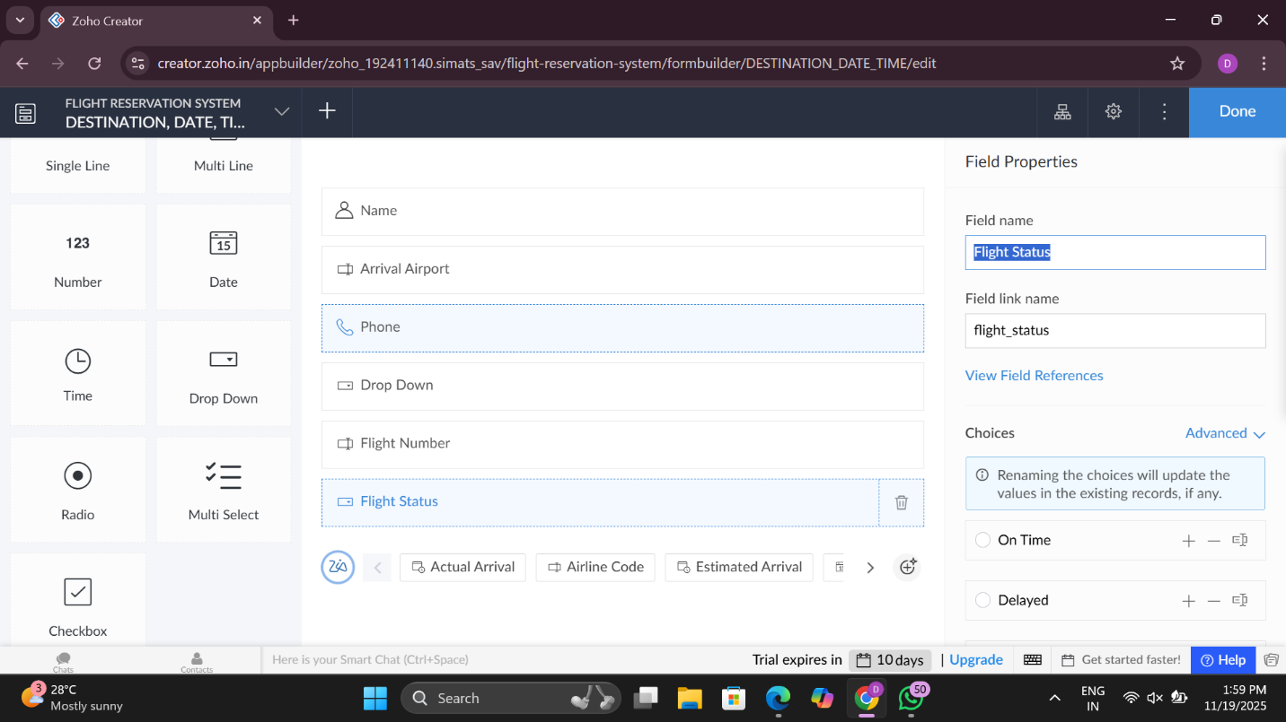

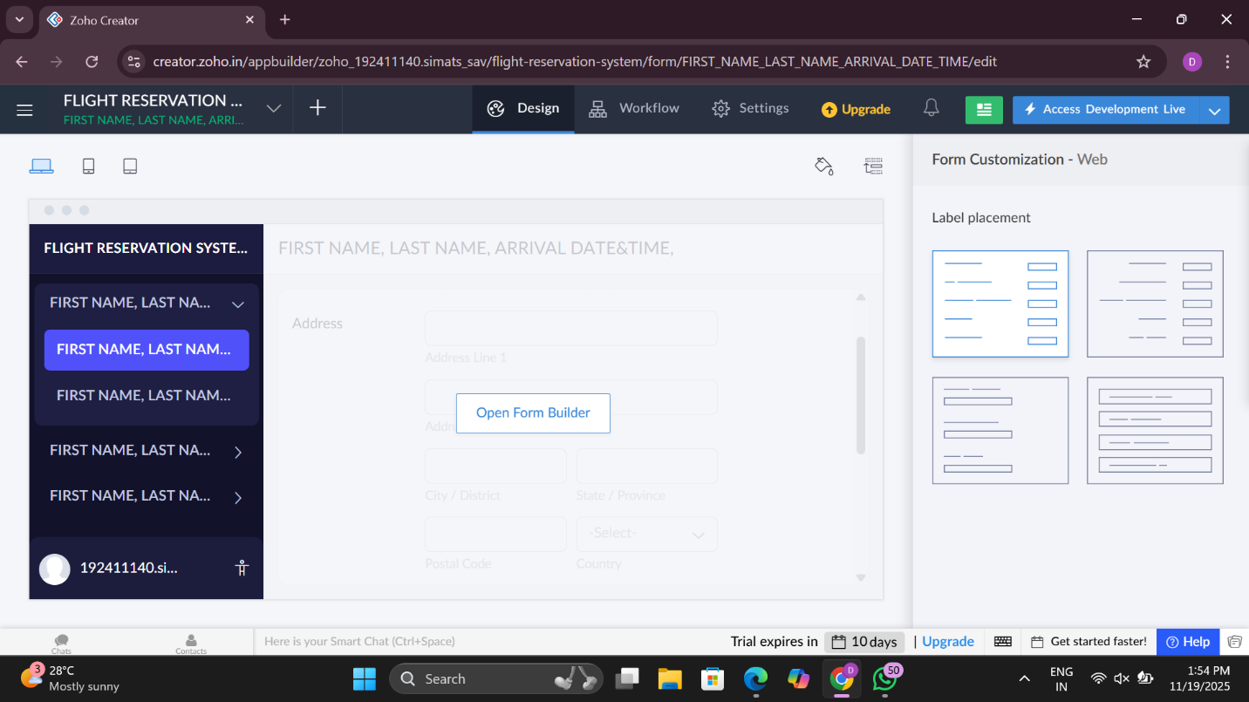

EXP NO:4
CREATE A SIMPLE CLOUD SOFTWARE APPLICATION FOR PROPERTY BUYING & RENTAL PROCESS (IN CHENNAI CITY) USING ANY CLOUD SERVICE PROVIDER TO DEMONSTRATE SAAS.
DATE:16/11/2025
DAY: SUNDAY
AIM:
To Create a simple cloud software application for Property Buying & Rental process (In Chennai city) using any Cloud Service Provider to demonstrate SaaS.
PROCEDURE:
1: Go to zoho.com. step
2: Log into the zoho.com. step
3: Select one application step. Step
4: Enter application name as property buying & rental. step
5: Created new application as property buying & rental. step
6: Select one form step 7: The software has been created.
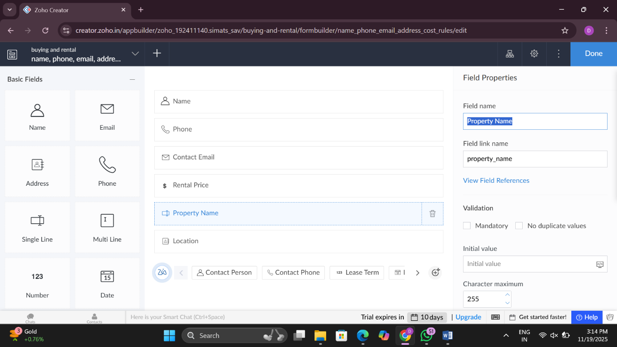
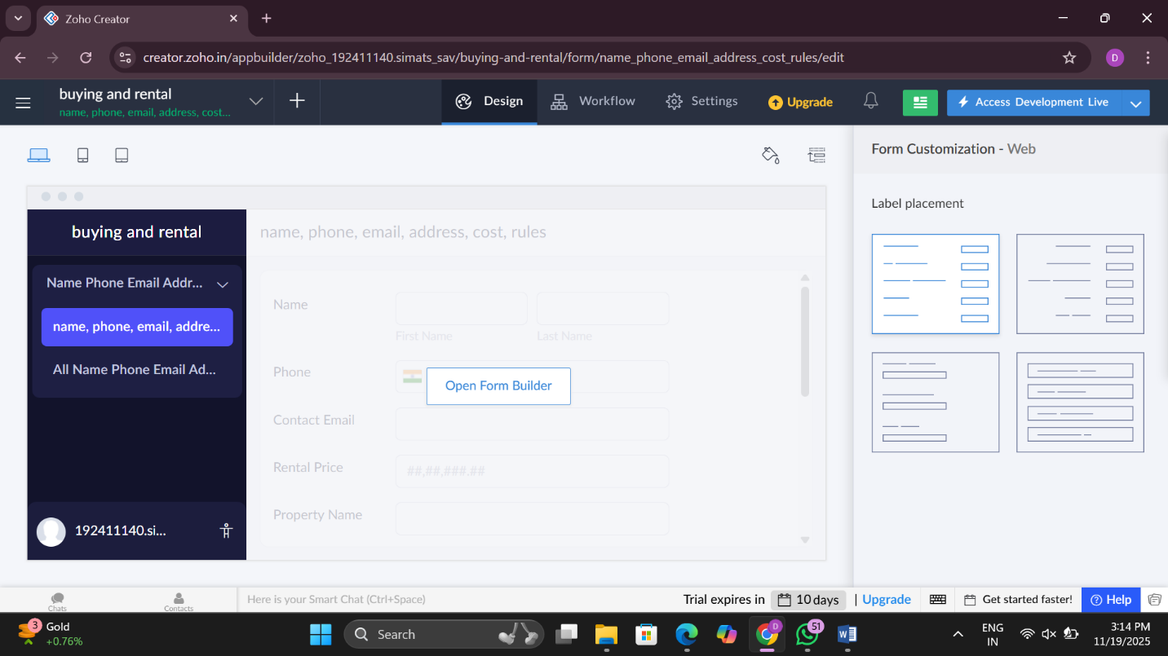

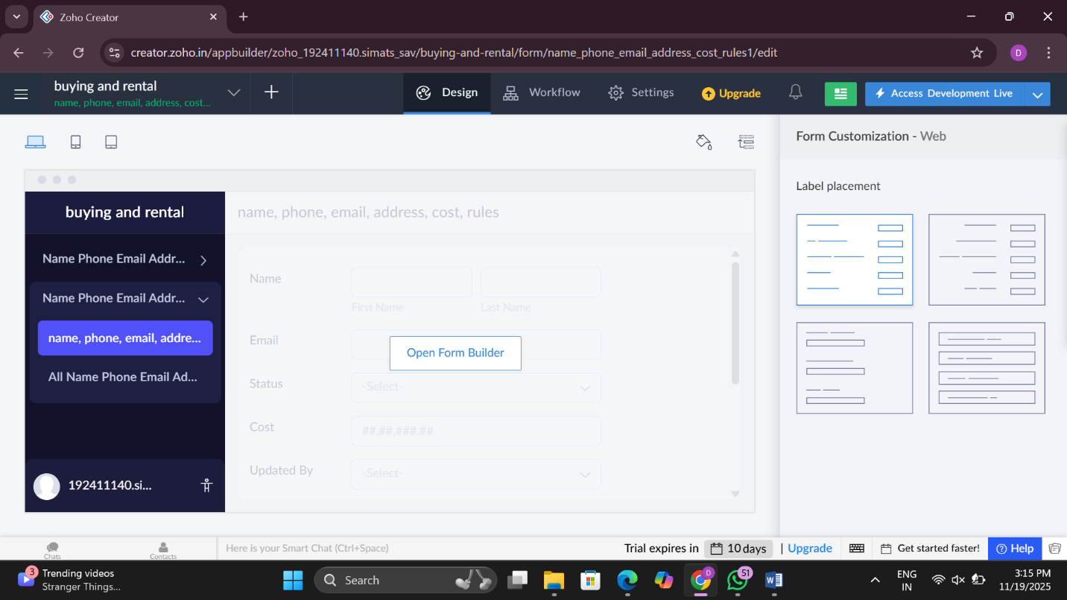

EXP NO 5: CREATE A SIMPLE CLOUD SOFTWARE APPLICATION FOR LIBRARY BOOK RESERVATION SYSTEM FOR SIMATS LIBRARY USING ANY CLOUD SERVICE PROVIDER TO DEMONSTRATE SAAS
DATE:16/11/2025
DAY: SUNDAY
AIM: To Create a simple cloud software application for Library book reservation system for SIMATS library using any Cloud Service Provider to demonstrate SaaS
PROCEDURE:
step1: Go to zoho.com.
step 2: Log into the zoho.com.
step 3: Select one application step.
step4: Enter application name as library book reservation system.
step 5: Created new application as library book reservation system.
step 6: Select one form step
7: The software has been created.
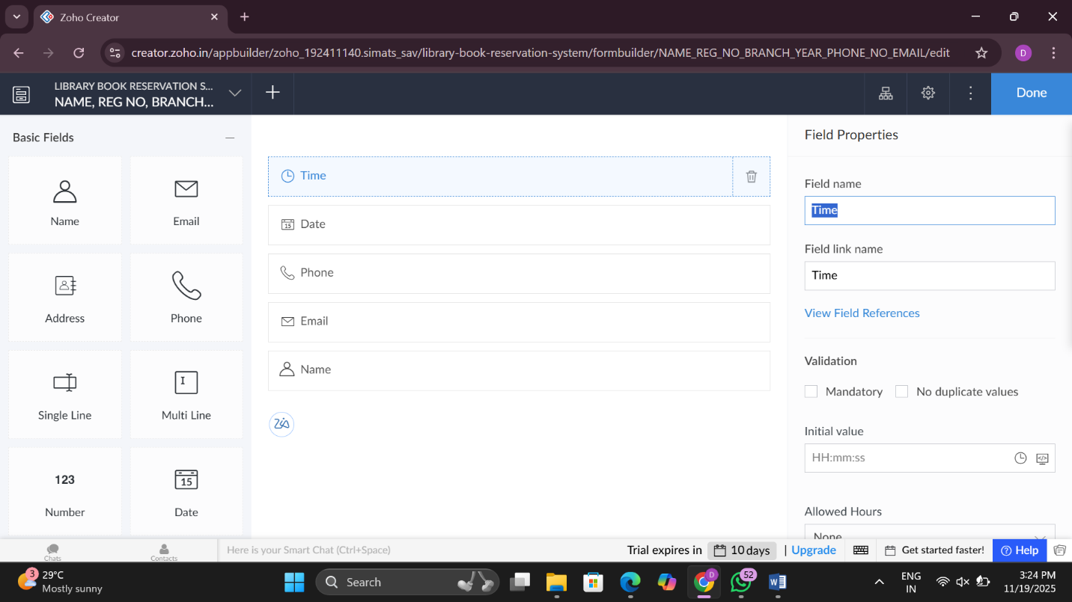
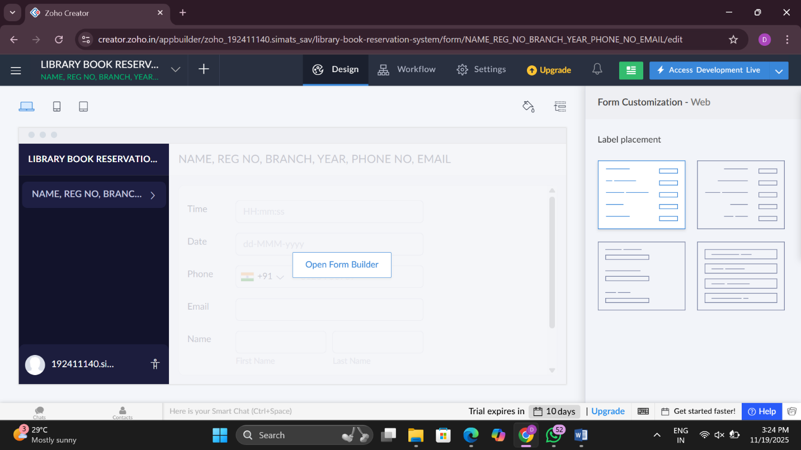

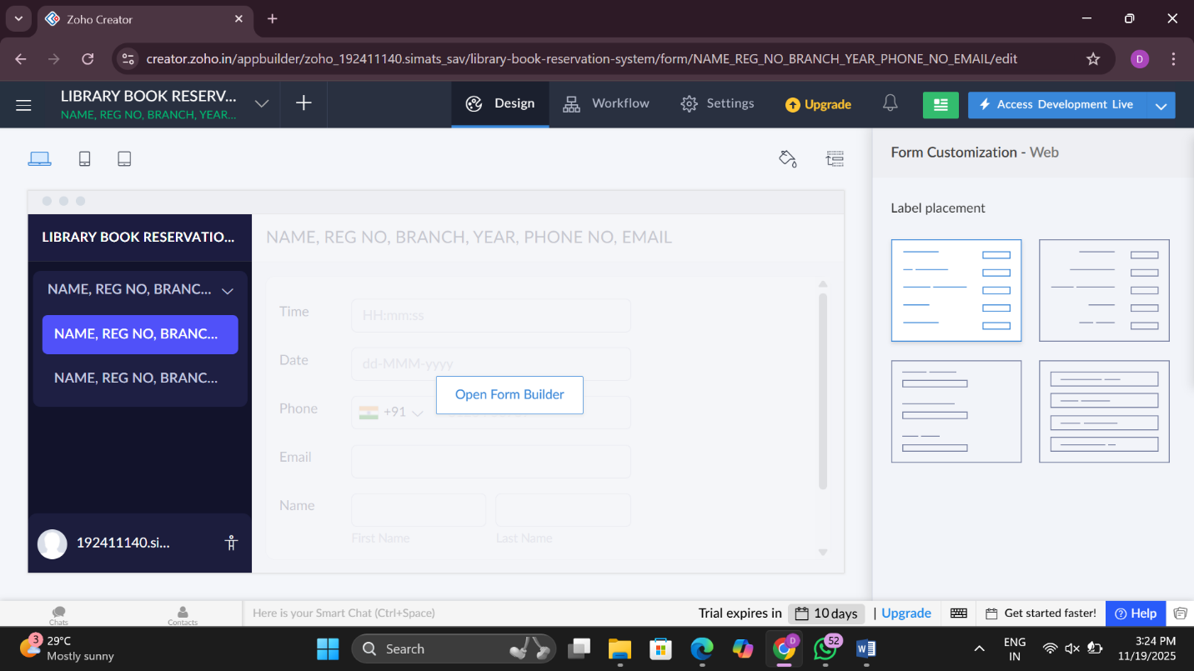

EXP NO 6: CREATE A SIMPLE CLOUD SOFTWARE APPLICATION FOR PRODUCT SELLING USING ANY CLOUD SERVICE PROVIDER TO DEMONSTRATE SAAS.
Date:16/11/2025
Day: sunday
AIM: To create a simple cloud software application for product selling using any cloud service provider to demonstrate saas.
PROCEDURE:
step1: Go to zoho.com.
step 2: Log into the zoho.com.
step 3: Select one application step.
step4: Enter application name as product selling.
step 5: Created new application as product selling.
step 6: Select one form step
7: The software has been created.

